**Tutorial 2 – Basic Player Movement**

* After the camera movement is complete, we now want to be able to move the player around. We start by adding a script to the First Person Player component and calling it “PlayerMovement”.
* Start by getting the input of your keyboard in the update section, as well as using the recorded input to make the player move into a direction by using Vector3 movement. You also want to make sure the script know what is being moved, which in this case is the First Person Player. This means we need to be able to reference the First Person Player in the script itself, which we do by creating a public class.

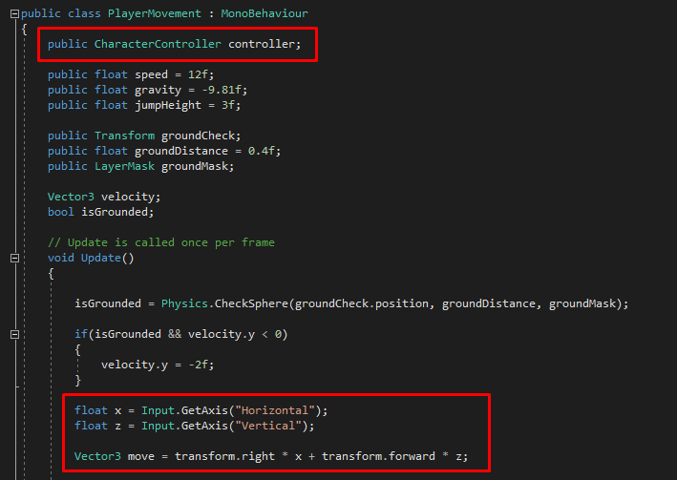

* 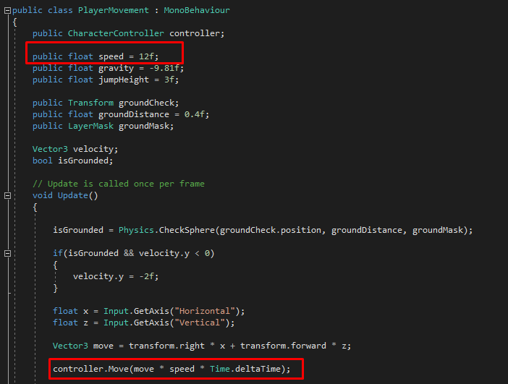You now want to add a public float to be able to change the speed within Unity, to better adjust it to your liking, as well as making sure the script updates accordingly with “time.deltaTime”.
* At last, make sure to reference the First Person Player component with the “PlayerMovement” script in Unity.

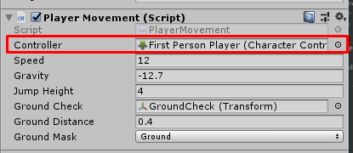

* 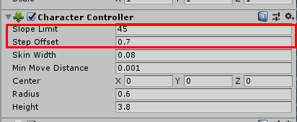Now in the Character controller, you can also adjust things such as the slope limit and the step offset, to make sure the player can, or cannot walk on certain objects.